Board: Battery Board V3

Belongs to: Applications Engineering

Point of Contact: Josh Brown

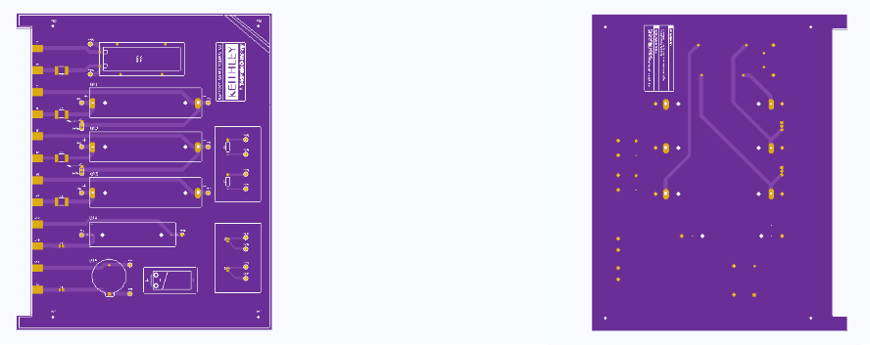

Components for each board (5 boards total):

* 18650 Battery Holders (x3)
* AA Battery Holder (x1)
* 20.0 mm Coin Cell Battery Holder (x1)
* Red Banana Jacks (x6)
* Black Banana Jacks (x6)
* Red Test Points (x10)
* Black Test Points (x10)
* 3-pin Headers (x2)
* 10k NTC Thermistors (x2)
* PTC Reset Fuse 6V 0.5 A 0805 (x2) (or 6V 1.25 A if prepping for pulse testing)
* PTC Reset Fuse 24V 2 A 2920 (x4) (or 24V 7 A 2920 if prepping for pulse testing)
* Anmbest 3S 11.1V/12V/12.6V 10A 18650 Charger PCB BMS (x1)
* Square Bumper Feet (x4)

Soldering and Assembly Instructions:

1. Solder the 6 fuses: 0805 (x2) and 2920 (x4) to the SMD terminals near the banana jack inputs (left side of the board based on the orientation above).
2. Solder the 10k NTC thermistors to the 2 SMD part pads in the lower right corner of the board (based on the orientation above).
3. Solder all 20 test points to the board (Red to positive traces, black to negative traces)
4. Solder banana connectors to the board (Red to positive traces, black to negative traces)
5. Solder 3-pin headers to the board
6. Solder wires to each terminal on the BMS
7. Secure the BMS to the board via Velcro (or additional methods if desired)
8. Solder the other end of the wire directly into the corresponding pad on the board
9. (Optional) Mount the board to surface using M2.5 mounting holes in the 4 corners of the board
10. Elevate the board using rubber/plastic feet

Congrats! The board is ready to go! Insert desired batteries into the battery holders and begin testing.